PPSNTH-83 / DA 10.2021.170.1 – Recommended conditions

DEFERRED COMMENCEMENT CONDITION PURSUANT TO SECTION 4.16(3)
The following condition concerns matters as to which the Council must be satisfied before the consent can be issued:

- Deferred Commencement Consent
This consent does not operate until Council is satisfied as to the following matters:

- Essential Energy approval
Written confirmation has been provided by Essential Energy (i) that they have no safety concerns with the proposed development, and (ii) of any requirements and/or conditions Essential Energy has for the development. The written confirmation from Essential Energy should also confirm that the new power cable crossing of the watercourse can follow the current road alignment.

- Targeted fauna surveys
The report titled Biodiversity Assessment – Linnaeus Property – Eco Tourism Mixed Use Proposal, UPR 2080-1086 prepared by GeoLINK and dated 01/02/2021 must be amended to be consistent with the approved plans and the requirements of this consent.

Additionally, targeted fauna surveys must be carried out across the entirety of Lot 1 DP1031848 and the results detailed in the amended report. At a minimum, the following fauna species must be targeted by surveys:
- Common planigale (Planigale maculata)
- Eastern grass owl (Tyto longimembris)
- White-eared monarch (Carterornis leucotis)
- Rose-crowned fruit-dove (Ptilinopus regina)
- Square-tailed kite (Lophoictinia isura)
- Pied oystercatcher (Haematopus longirostris)
- Eastern blossom bat (Syconycteris australis)
- Eastern long-eared bat (Nyctophilus bifax)
- Wallum sedge frog (Litoria olongburensis)

Targeted fauna surveys must be carried out during the time specified for the species in the NSW Threatened Biodiversity Data Collection and must be in accordance with the following guidelines:
- Threatened Biodiversity Survey and Assessment: Guidelines for Developments and Activities (NSW Department of Environment and Conservation 2004)
- Threatened species survey and assessment guidelines: field survey methods for fauna – amphibians (NSW Department of Environment and Climate Change 2009)

- Management of indirect impacts on fauna
Provision of detailed plans and specifications that demonstrates impacts from the development on fauna from lighting will be minimised to the greatest practicable extent. The plans and specifications must be prepared in accordance with the best practice lighting design principles in the National Light Pollution Guideline for Wildlife (Department of Environment and Energy, January 2020) and must include, but not be limited to:
- Minimal external lighting located close to the ground, away from reflective surfaces, with adaptive, timing controls and reduced and/or filtered wavelengths;
- Provision of torches in cabins for use by guests; and
- Use of adaptive lighting controls for internal lighting and use of blinds or equivalent to minimise light spill from buildings.
Details of measures to minimise the impacts of the development on fauna from noise and vehicle strikes including, but not limited to:
- Restricting amplified music and voices;
- Restricting evening use of the “food offering” (CB.04) building;
- Signage in cabins and ancillary building informing guests of possible impacts on fauna from noise and vehicle strikes; and
- Restricting traffic/vehicle movements during high risk times for vehicle strikes.

- Provision of a Vegetation Management Plan
A Vegetation Management Plan (VMP) must be prepared and submitted to Council for approval. The VMP must retain and improve habitat on that part of the site covered by the VMP and must detail measures to protect native flora and fauna and their habitats and environmental enhancement planting. The VMP must:
- illustrate on maps of a suitable scale (1:200 or better) the accurate extent of bush fire asset protection zones (APZs) for the development and the location and extent of areas for enhancement and/or planting on the subject site. The areas for enhancement planting must include, but not be limited to, the “proposed rainforest” areas and riparian zone of the watercourse (labelled “existing drain”) on Precinct Plan – APZ (C.01. Revision 15, 27/09/2022) areas.
- Ensure that additional locations for enhancement and planting are informed by the targeted fauna survey effort, focusing on areas that presently have low habitat value for native flora and fauna.
- Ensure that locations for enhancement and planting are additional to, and do not overlap with, any environmental enhancement works required by, or committed to under, previous development consents for the property.
- for each location identified for enhancement and planting indicate the area, proposed density of planting and total number of plants to be planted in plan and word form and demonstrate that the equivalent of 10,800 plantings or an area of 6.72 ha (based on a density of 2.5m/tree) will be restored and/or enhanced.
- indicate that only local vegetation will be planted and include a list of locally occurring native tree, shrub and ground cover plant species suitable for planting as part of the environmental enhancement planting program.
- detail the methodology for habitat restoration and maintenance over a minimum period of 10 years and specifying the use of qualified and experienced bush regenerators only.
- detail weed control, monitoring and management of the areas covered by the VMP and routine reporting of progress.
- specify timelines for the planting and/or restoration works including commencement prior to the issue of the construction certificate.
- Be in accordance with the “BSC Guidelines for preparing: Vegetation Management Plans (VMP) or Biodiversity Conservation Management Plans (BCMP).
- Include a program of vegetation management actions over a minimum period of 10 years.

- Amendment to current development consents in relation to wastewater management
Any conditions/requirements in current development consents and associated approvals under s.68 of the Local Government Act 1993 for the property relating to the management, treatment and disposal of wastewater that conflict with the changes and upgrades approved by this consent must be identified and made consistent with the requirements of this consent. It is envisaged that this process may require one or more applications to modify a consent under s.4.55 of the Environmental Planning and Assessment Act 1979 to be lodged and determined.

Evidence is required to be submitted of compliance with the above condition, sufficient to satisfy the Council as to those matters, within 2 years of the date of this Notice of Determination. If satisfactory evidence is produced in accordance with this requirement, the Council will give written notice to the applicant of the date from which this consent commences operation.
If Council has not notified the applicant within a period of 28 days after the applicant’s evidence is produced to it, the Council is, for the purposes only of Section 8.7 of the Environmental Planning and Assessment Act 1979, taken to have notified the applicant that Council is not satisfied as to those matters on the date on which that 28-day period expires.

CONDITIONS OF CONSENT
Upon satisfaction of the deferred commencement condition/s, the following conditions apply:
Parameters of consent
Approved plans and supporting documentation
Development must be carried out in accordance with the following approved plans and supporting documentation (stamped by Council), except where the conditions of this consent expressly require otherwise.

Plan No. | Revision No. | Plan Title | Drawn by | Dated
DA 03 | 15 | CB.01 – Centre Additions | Harley Graham Architects | 27/09/2022
DA 04 | 15 | CB.02 – Reception Building | Harley Graham Architects | 27/09/2022
DA 05 | 15 | CB.02 – Reception Building | Harley Graham Architects | 27/09/2022
DA 06 | 15 | CB.03 – Onsite Evacuation Building | Harley Graham Architects | 27/09/2022
DA 07 | 15 | CB.04 – Wellness + Pool Facilities | Harley Graham Architects | 27/09/2022
DA 08 | 15 | CB.04 – Wellness + Pool Facilities | Harley Graham Architects | 27/09/2022
DA 09 | 15 | CB.04 – Wellness + Pool Facilities | Harley Graham Architects | 27/09/2022
DA 10 | 15 | CB.04 – Wellness + Pool Facilities | Harley Graham Architects | 27/09/2022
DA 11 | 15 | CB.06 – Store & Utility | Harley Graham Architects | 27/09/2022
DA 12 | 15 | B – Rainforest Retreat TYPICAL | Harley Graham Architects | 27/09/2022
DA 13 | 15 | B – Rainforest Retreat Sections A | Harley Graham Architects | 27/09/2022
DA 14 | 15 | B – Rainforest Retreat Sections B | Harley Graham Architects | 27/09/2022
DA 15 | 15 | Materials Schedule | Harley Graham Architects | 27/09/2022
B.01 | 15 | Precinct Plan A - Satellite | Harley Graham Architects | 27/09/2022
C.01 | 15 | Precinct Plan - APZ | Harley Graham Architects | 27/09/2022
D.00 | 15 | Precinct & Key Plan A | Harley Graham Architects | 27/09/2022
D.01 | 15 | Vegetation Analysis – Fig 1 | Harley Graham Architects | 27/09/2022
D.02 | 15 | Vegetation Analysis – Fig 2 | Harley Graham Architects | 27/09/2022
K.01 | 15 | Riparian Corridor (Offset Plan) | Harley Graham Architects | 27/09/2022

In the event of any inconsistency between the approved plans and the supporting documentation, the approved plans prevail. In the event of any inconsistency between the approved plans and a condition of this consent, the condition prevails.

Note: an inconsistency occurs between an approved plan and supporting documentation or between an approved plan and a condition when it is not possible to comply with both at the relevant time.

Conditions prescribed by the Regulation
This development consent is subject to the conditions prescribed by the regulations in accordance with subsection 4.17(11) of the Environmental Planning and Assessment Act 1979. Conditions are provided in a Schedule of this consent.

Facilities only for use by guests
The facilities and ancillary buildings associated with the eco-tourist facility are only approved to be used by guests of the eco-tourist facility and private education facility. The facilities and ancillary buildings are not approved for day use by external visitors to the property/site as the wastewater treatment plant and disposal system has not been designed and/or constructed to have sufficient capacity for additional wastewater loads beyond established maximum occupancy/guest numbers.

Tree Removal
The development must not cause, or result in, any native trees, shrubs or plants being removed from the site.

Integrated Approvals from other State Government Approval Bodies
This development consent includes integrated development approvals under Sections 4.46 and 4.47 of the Environmental Planning and Assessment Act 1979, being:
- an authorisation under section 100B of the Rural Fires Act 1997 in respect of bush fire safety of a development of land for special fire protection purposes; and
- an activity approval under Part 3 of Chapter 3 of the Water Management Act 2000;

and is subject to the General Terms of Approval from the NSW Rural Fire Service dated 30 august 2022 and from the Department of Planning and Environment dated 2 September 2022 contained in Schedule X of this Notice of Determination.

The following conditions are to be complied with prior to issue of a Construction Certificate for building works
Construction site management plan
Before the issue of a construction certificate, the applicant must ensure a construction site management plan is prepared before it is provided to and approved by the certifier. The plan must include the following matters:
- location and materials for protective fencing and hoardings to the perimeter on the site
- provisions for public safety
- pedestrian and vehicular site access points and construction activity zones
- details of construction traffic management, including proposed truck movements to and from the site and estimated frequency of those movements, and measures to preserve pedestrian safety in the vicinity of the site
- protective measures for on-site tree preservation (including in accordance with AS 4970-2009 Protection of trees on development sites and Council’s DCP, if applicable) and trees in adjoining public domain (if applicable)
- details of any bulk earthworks to be carried out
- location of site storage areas and sheds
- equipment used to carry out all works
- a garbage container with a tight-fitting lid
- dust, noise and vibration control measures
- location of temporary toilets.

The applicant must ensure a copy of the approved construction site management plan is kept on-site at all times during construction.

Essential Energy approval
A copy of the written confirmation from Essential Energy, provided to satisfy deferred commencement condition 1(a), must be submitted with the construction certificate application.

Initial ecological restoration required by approved Vegetation Management Plan
Certification by an appropriately qualified and experienced ecologist and/or bush regenerator must be provided that confirms that all initial ecological restoration and management actions specified in the approved Vegetation Management Plan to be completed prior to the issue of a construction certificate have been carried out.

Solar energy plan
The application for a Construction Certificate is to include plans and specifications for the installation of at least 250kW solar photo voltaic system in conjunction with at least 700kWh of battery storage for the development. The plan of proposed solar energy generation and storage for the development must include a management plan that details the timing for installation of the solar photo voltaic and battery system and how reliance on energy from the grid will be minimised and/or avoided within 5 years from the commencement of construction of the development.

The plans and specifications are to be approved as part of the Construction Certificate.

Water efficiency and re-use plan
The application for a Construction Certificate is to include plans and specifications for water efficiency and re-use measures to be implemented for the development including the installation of rainwater tanks for each new building associated with the approved eco-tourist facility. Each cabin must have a rainwater tank with a capacity of at least 9000L exclusive of any additional water storage required for firefighting purposes required by this development consent. Details of the use of water collected in rainwater tanks must be provided including, but not limited to, water for toilet flushing, external taps and irrigating landscaping.

Such plans are to be approved as part of the Construction Certificate.

Environmental Management Plan required
TBF - Provision of and implementation of an environmental management plan, environmental policy, environmental impacts and aspects identification, targets and objectives and operational emergency procedures.
Amendments to the plans required
The plans submitted for approval of the Construction Certificate must be amended as follows:
- Delete/remove the boardwalk spanning from the Reception Building (CB.02) to Foundation Drive as shown on Plan D.01 (revision 15, 27/09/2022).
- Delete/remove the cabin swimming pools, labelled ‘Plunge pool’ on Plan D.12 (revision 15, 27/09/2022).
- To provide elevations and sections for the Bin Store & Garbage structure adjacent to the Centre building (CB.01) as shown on plan DA 03 (revision 15, 27/09/2022).
- Delete/remove the “bike store” as shown on Plan DA 11 (revision 15, 27/09/2022). Bicycle storage may be relocated to the Reception building (CB.02) but must be covered/roofed, in view/obvious to guests and co-located with end-of-trip facilities including toilets and /showers.

Such plans are to be approved as part of the Construction Certificate.

Erosion and Sediment Control Plan required
The application for a Construction Certificate is to include an Erosion and Sediment Control Plan that details the measures to be employed to control erosion and loss of sediment from the site during construction. The Erosion and Sediment Control Plan must:
- be in accordance with Council's current “Northern Rivers Local Government Development Design & Construction Manuals and Standard Drawings”;
- include a cut and fill plan that shows the location and extent of earthworks required for the development;
- include cross-sections for proposed earthworks particularly in relation to buildings in proximity to the watercourse (Store & Utility – CB.06 and Reception Building – CB.02); and
- demonstrate control over the discharge of stormwater and containment of run-off and pollutants leaving the site/premises through the installation of erosion control devices such as catch drains, energy dissipaters, level spreaders and/or sediment control devices such as filter fences and sedimentation basins.

The Erosion and Sediment Control Plan must be approved as part of the Construction Certificate.

Details of stormwater drainage
The application for a Construction Certificate is to include plans and specifications for stormwater drainage in accordance with AS/NZS 3500.3:2003, Plumbing and drainage, Part 3: Stormwater drainage. All stormwater new buildings and hardstand areas must be conveyed by a gravity system to the watercourse (labelled as existing drain on Plan B.01 (revision 15, 27/09/2022). Such plans and specifications must be approved as part of the Construction Certificate.

The following features must be included in the design of the stormwater drainage for the development:
- Stormwater flows from minor and major storm events are to stay aboveground using vegetated swales or similar.
- Rainwater tanks for each new building in accordance with the water efficiency and re-use plan.
- Overflow from rainwater tanks to be directed to constructed gravel pits.
- Vegetation of the watercourse to provide water quality treatment during the flow of stormwater through the site.
- Energy dissipators at stormwater outlet points to the watercourse.
- An additional stormwater quality measures required to meet the objectives of Table B3.1 of Chapter B3 of DCP 2014.

Car parking layout, vehicle circulation and access plans required
The application for a Construction Certificate is to include plans and specification that indicate access, vehicle parking and manoeuvring details in accordance with the plans approved by this consent.

In relation to car parking, twelve car parking spaces, of which two must be accessible, must be provided for the eco-tourist facility development. Provision of the required car parking spaces under this development consent may utilise existing car parking on site but must not result in a car parking shortfall for the property (see Note). Parking user class 2 and class 4 must be adopted for general parking and accessible parking respectively.

The site access controlled gate must be moved at least 4m further into the site to accommodate 24m of traffic queue length on the driveway, details of which must be provided.

The access, vehicle parking and footpaths for the site are to comply with the requirements of Australian Standard (AS) 2890.1-2004: Parking facilities, Part 1: Off-street car parking, AS 2890.2 – 2010 - Parking facilities, Part 2: Off-street commercial vehicle facilities and Council's current “Northern Rivers Local Government Development Design & Construction Manuals and Standard Drawings”.

Plans and specifications for any new vehicle access, parking and manoeuvring works are to include, but not be limited to, the following items:
- Pavement design, comprising an all-weather surface, such as asphalt, bitumen seal, concrete, pavers or other similar treatment;
- Site conditions affecting the access;
- Current and design levels;
- Longitudinal section from the road centreline to the car space(s);
- Drainage details;
- Turning paths; and
- Line marking and signage.

A pedestrian access mobility plan (footpath network) must also be provided.

The plans and specifications are to be prepared by a qualified, practicing Civil Engineer with relevant experience and competence. The Civil Engineer is to be a corporate member of the Institution of Engineers Australia, or eligible to become a corporate member.

Such plans and specifications must be approved as part of the Construction Certificate.

Note: Development consents for the property have not been fully utilised with some approved buildings not yet being constructed. It is estimated that 78 car parking spaces are required if all development consents for the property are fully enacted with 63 car parking space being currently available.

Drinking Water Management System required
The application for a Construction Certificate is to include a Drinking Water Management System or Quality Assurance Program for Drinking Water for the development in accordance with the requirements of New South Wales Private Water Supply Guidelines (http://www.health.nsw.gov.au/environment/water/Publications/private-water-supply-guidelines.pdf).

The Drinking Water Management System or Quality Assurance Program for Drinking Water for the development must be prepared by a suitably qualified and experienced professional.

The Drinking Water Management System or Quality Assurance Program for Drinking Water for the development must be approved as part of the Construction Certificate.

Upgrade of on-site sewage management facility
The current wastewater treatment system for the property must be upgraded to accommodate the additional wastewater expected to be generated from the proposed development. The necessary upgrades to the wastewater treatment system are detailed in the Technical Memorandum RE: Consolidated description of the Wastewater Arrangements concerning DA 2021-170 (Planners North, 15 October 2021) particularly Sections 4 and 5.

An approval under Section 68 of the Local Government Act 1993 for on-site sewage disposal must be obtained from Council prior to issue of a Construction Certificate. Such approval must be issued after the date of this consent.

The application for Section 68 approval must be accompanied by a report prepared by a suitably qualified professional with demonstrated experience in sewage treatment and disposal, which addresses the site specific design requirements for sewage management in accordance with the requirements of the Local Government Act 1993, and Regulation and Guidelines approved by the Director General.

Water and Sewerage - Section 68 approval required
If required, an Approval under Section 68 of the Local Government Act 1993 to carry out water supply work and sewerage work must be obtained.

Trees to be retained and protected
All trees within 10m of new development approved by this consent must be illustrated on all relevant construction plans, with the corresponding tree protection zone (TPZ) formulated in accordance with AS 4970-2009 – Protection of Trees on Development Sites.

Trees within 10m of new development are to be protected by a TPZ exclusion fence. The fence is to be constructed in accordance with Sections 3.2 and 4.3 of AS 4970-2009 and must:
- Be located outside the dripline of the tree to minimise disturbance of tree roots;
- have a minimum height of 1.8m;
- be constructed of wire mesh panels, plywood, steel star pickets or similar, with a maximum distance of 2m between star pickets;
- have a minimum of 3 strands of steel wire or similar;
- have high visibility barrier mesh (e.g., orange), shade cloth or similar, attached to the outside of the fence and continuing around its perimeter; and
- include at least one TPZ sign in accordance with Section 4.4 of AS 4970-2009.

Activities that are excluded within the TPZ (as per section 4.2 of AS 4970-2009) include excavation, construction activity, grade changes, surface treatment and storage of material. If these activities are required within the TPZ they may only occur under the supervision of the project arborist (minimum AQF level 5 qualified arborist).

Updated landscaping plan required
The application for a Construction Certificate is to include an amended Landscaping Plan that incorporates adequate detail to demonstrate compliance with the relevant provisions of Chapters B9 of the Byron Shire Development Control Plan 2014 including:
a) retention of suitable existing vegetation;
b) landscaping that minimises visual impacts of the development;
c) landscaping that minimises bushfire hazard; and
d) planting selection that is locally indigenous to locality and improves biodiversity where possible.

The updated landscaping plan should include consideration of the following landscaping for privacy and reduction of visual impacts:
- between individual cabins ;
- between cabins B.1 and B.8 and the driveway; and
- between the western cabins (B.8 to B.12) and the pool/tennis court complex.

The landscaping plan must indicate:
- proposed location for planted shrubs and trees;
- botanical name of shrubs and trees to be planted;
- planting of locally endemic, native species;
- mature height of trees and shrubs to be planted;
- location of grassed and paved areas; and
- location of trees identified for retention in the development application plans.

The plan is to be prepared by a suitably qualified landscape architect / architect /ecologist who has appropriate experience and competence in landscaping.

Such plans and specifications must be approved as part of the Construction Certificate.

Section 7.12 development consent levy to be paid
The levy will be calculated as follows:

Levy payable = %C x $C
- %C is the levy rate applicable as set out in the latest Ministerial Direction issued under Section 7.17 of the Environmental Planning and Assessment Act 1979.
- $C is the proposed cost of carrying out the development.

The rate of %C is:
Proposed cost of the development | Maximum percentage of the levy
Up to $100,000 | Nil
$100,001–$200,000 | 0.5 percent
More than $200,000 | 1.0 percent

The cost of development must be calculated in accordance with clause 25J of the Regulation. The Cost Summary Report as set out in schedule 2 of the Section 7.12 contributions plan must be submitted to Council with the payment. The cost summary report must be prepared by a quantity surveyor. Copies of the cost summary report are available at Council’s main office or may be downloaded from Council’s website.

Building materials and colours to be specified
The application for a Construction Certificate is to include plans and specifications that indicate the proposed building materials and colours generally in accordance with the approved Materials Schedule (DA 15, Revision 15, 27/09/2022). All metal roof sheeting must be medium or dark tone to minimise visual impacts. White and near white colours is not permitted for any external finishes.

Such plans and specifications must be approved as part of the Construction Certificate.

Compliance with BASIX Certificate requirements
The development is to comply with BASIX Certificate No. 1055410M_03, dated 3/2/2021.

The commitments indicated in the Certificate are to be indicated on the plans submitted for approval of the Construction Certificate.

The plans submitted must clearly indicate all windows numbered or identified in a manner that is consistent with the identification on the BASIX Certificate.

Minor changes to the measures may be undertaken without the issue of any amendment under Section 4.55 of the Act, provided that the changes do not affect the form, shape or size of the building.

Such plans and specifications must be approved as part of the Construction Certificate.

Long Service Levy to be paid
In accordance with Section 6.8 of the Environmental Planning and Assessment Act 1979 (as amended), a Construction Certificate for BUILDING WORKS shall NOT be issued until any Long Service Levy payable under Section 34 of the Building and Construction Industry Long Service Payments Act, 1986 (or where such levy is payable by instalments, the first instalment of the levy) has been paid (as applicable).

These payments can be made online at www.longservice.nsw.gov.au. Proof of payment is required to be submitted with the Construction Certificate application.

For further information regarding the Long Service Payment please refer to the website above.

Updated Waste Management Plans
Before the issue of a construction certificate, the applicant is to provide:
- A construction waste management plan; and
- An operation waste management plan.

The waste management plans must be prepared in accordance with the EPA’s Waste Classification Guidelines and Chapter B8 of Byron Shire Development Control Plan 2014 (DCP 2014) and must specify the proposed method of recycling or disposal and the waste management service provider.

The construction waste management plan should be generally in accordance with Construction Waste Management Plan Eco Tourism Mixed Use Proposal Broken Head (Planners North, January 2021) and should detail the measures to ensure 90% of construction waste is diverted from landfill through reuse and/or recycling.

The operational waste management plan must include, but not be limited to:
- Updated predicted waste generation from the development;
- Details of commitments to ensure single use plastics are avoided and reusable containers are used where practicable; and
- Details of management of organic wastes including the proposed composting/worm farm system.

A template is provided on Council’s website to assist in providing this information www.byron.nsw.gov.au/files/publication/swmmp - pro-forma-.doc

The following conditions are to be complied with prior to any building or construction works commencing
Erosion and Sediment Control
Erosion and sediment controls are to be in place in accordance with the approved Erosion and Sediment Control Plan prior to building or construction works commencing.

Toilet facilities
Toilet facilities are to be provided, at or in the vicinity of the work site at the rate of one toilet for every 20 persons or part of 20 persons employed at the site. Each toilet provided must be a toilet connected to an accredited sewage management system approved by the Council.

The following conditions are to be complied with during any building or construction works
Hours of work
The principal certifier must ensure that building work, demolition or vegetation removal is only carried out between:
- 7am to 6pm on Monday to Friday.
- 8am to 1pm on Saturday.

The principal certifier must ensure building work, demolition or vegetation removal is not carried out on Sundays and public holidays, except where there is an emergency.

Unless otherwise approved within a construction site management plan, construction vehicles, machinery, goods or materials must not be delivered to the site outside the approved hours of site works.

Note: Any variation to the hours of work requires Council’s approval.

Construction Noise
While building work is being carried out, the applicant is to ensure that any noise caused by demolition or construction does not exceed an LAeq (15 min) of 5dB(A) above background noise, when measured at any lot boundary of the property where the construction is being carried out.

Tree protection zone fencing to be maintained
The Tree Protection Zone (TPZ) exclusion fence is to be maintained for the duration of the site clearing, preparation, construction and landscaping works.

Inspection for on-site sewage management
All plumbing and drainage works associated with on-site sewage management are to be installed by a suitably qualified person. The plumbing and drainage works must adhere to the requirements of the NSW Code of Practice and AS 3500. The following inspections must be arranged with Council:
- Internal drainage prior to covering of the works.
- External drainage prior to the covering of works.
- Irrigation installation prior to the covering of works.
- Final

Implementation of BASIX commitments
While building work is being carried out, the applicant must undertake the development strictly in accordance with the commitments listed in the BASIX certificate(s) approved by this consent, for the development to which the consent applies.

Signs to be erected on building and demolition sites
A sign must be erected in a prominent position on the work site:
a. stating that unauthorised entry to the work site is prohibited, and
b. showing the name of the person in charge of the work site and a telephone number at which that person may be contacted outside working hours.

Any such sign is to be removed when the work has been completed.

Building rubbish to be contained on site
Rubbish and waste generated during building and construction is to be contained on the site in a ‘Builder’s Skip’ or similar enclosure. Footpaths, road reserves and public reserves are to be maintained clear of rubbish, building materials and all other items.

Maintenance of erosion and sediment controls
Erosion and sediment controls must be maintained in accordance with the approved Erosion and Sediment Control Plan and until the site has been stabilised by permanent vegetation cover or hard surface.

Removal of wastes
All wastes associated with the building and construction works are to be handled, and disposed of, in accordance with the requirements of the Work Cover Authority. Wastes must be disposed of at a Licenced Waste Facility. All wastes removed from the site must be managed and disposed of in accordance with the NSW EPA Waste Classification Guidelines (2014)

Documentary evidence that this condition has been complied with must be provided to Council on request.
Excavated natural materials and waste disposal
Any and all excavated natural materials and builders waste transported from the site must be accompanied (a copy kept with the transporter) by a NSW Protection of The Environment Operations Act s143 Notice.

Discovery of relics or Aboriginal objects
Subject to the express requirements below, the building and construction works must be carried out in accordance with the recommendations in the Aboriginal Cultural Heritage Assessment Report (Everick Heritage, Revision 9, November 2019) provided with the development application.

Demolition, building or construction works must cease immediately if a relic or Aboriginal object is unexpectedly discovered. The applicant must notify the Heritage Council of NSW of the discovery of a relic and Secretary of the Department of Planning, Industry and Environment of the discovery an Aboriginal object. Demolition, building or construction works may recommence at a time confirmed by either the Heritage Council of NSW or the Secretary of the Department of Planning, Industry and Environment.

In this condition:
- “relic” means any deposit, artefact, object or material evidence that:
- relates to the settlement of the area that comprises New South Wales, not being Aboriginal settlement, and
- is of State or local heritage significance; and
- “Aboriginal object” means any deposit, object or material evidence (not being a handicraft made for sale) relating to the Aboriginal habitation of the area that comprises New South Wales, being habitation before or concurrent with (or both) the occupation of that area by persons of non-Aboriginal extraction and includes Aboriginal remains.

Site Location
The location of the buildings on the site must be established by a suitably qualified Surveyor and must confirm that all buildings and structures approved by this consent are located:
- At least 80m from the eastern property boundary;
- West of land affected by predicted coastal erosion (referred to as coastal erosion precincts on Council’s GIS); and
- At least 10m from the invert/centreline of the watercourse identified in the Riparian Corridor (Offset Plan) (K.01, Revision 15, 27/09/2022).

The following conditions are to be complied with prior to occupation of the building
Works to be completed prior to issue of a Final Occupation Certificate
All of the works indicated on the plans and approved by this consent, including any other consents that are necessary for the completion of this development including approvals issued under the Local Government Act 1993 and the Roads Act 1993, are to be completed and approved by the relevant consent authority/s prior to the issue of a Final Occupation Certificate.

Any Security bond paid for this application will be held until Council is satisfied that no further works are to be carried out that may result in damage to Council’s road/footpath reserve.

Internal driveway, footpath and vehicle parking areas in accordance approved plans
The internal driveway, footpath and vehicle parking areas are to be constructed from the property boundary to the proposed car space(s) in accordance with the approved plans.

Stormwater disposal
Stormwater must be collected and disposed of in accordance with the stormwater drainage design plans approved as part of the Construction Certificate and such that stormwater flows are:
- Clear of buildings and infrastructure,
- Not concentrated so as to cause soil erosion, and
- Not onto adjoining land.

Plumbing works – final certificate
All works in relation to any associated Section 68 Water and Sewerage approval must be fully complied with and have a Final Plumbing Certificate issued prior to the issue of an Interim or Final Occupation Certificate.”

On-site Sewage Management system must be completed
The on-site sewage management system is to be constructed in accordance with approved plans and in accordance with current specifications and standards. The system is not to be used and/or operated until a Council Officer has inspected the system and authorised its use.

Approval to Operate required
In accordance with the Local Government Act 1993, an Approval to Operate the onsite sewage management system must be obtained from Council. Forms may be downloaded from Council’s website with 'http://www.byron.nsw.gov.au/on-site-sewage'.

Compliance with solar energy plan
Documentary evidence from a suitably qualified and experienced expert must be submitted demonstrating that the solar energy plan provided with the construction certificate application has been complied with.

Site Location Survey
A final survey of the buildings and structures showing setbacks to the eastern property boundary, coastal erosion precincts and watercourse invert/centreline is to be submitted to the Private Certifier with the Occupation Certificate demonstrating compliance with condition x and the approved plans.

Compliance with bush fire conditions
Documentary evidence from a suitably qualified and experienced bush fire expert must be submitted demonstrating that the bush fire conditions referred to in condition x and attached to this Notice of Determination have been complied with.

The following conditions are to be complied with at all times
Approved use
Use of the development is approved for eco-tourist facility. Any activity other than the approved uses must not be carried out on the site without development consent. The use of the development and associated facilities is for overnight staying guests only. The maximum occupancy of the eco-tourist facility is 24 guests.

Note:
Eco-tourist facility means a building or place that—
(a) provides temporary or short-term accommodation to visitors on a commercial basis, and
(b) is located in or adjacent to an area with special ecological or cultural features, and
(c) is sensitively designed and located so as to minimise bulk, scale and overall physical footprint and any ecological or visual impact.
It may include facilities that are used to provide information or education to visitors and to exhibit or display items.

Car parking spaces are to be available for the approved use
Twelve (12) car parking spaces are to be provided and maintained for the eco-tourist facility, together with all necessary access driveways and turning areas, to the satisfaction of Council.

Provision and quality of drinking water
The provision of drinking water for the development must be in accordance with the approved Drinking Water Management System or Quality Assurance Program for Drinking Water for the development. Results of routine water quality monitoring must be kept for at least two years and provided to Council on request.

Rainwater Supply
Any rainwater tanks used for domestic water supply are required to divert water from the first rainfall using a first flush or bypass device.

Prevention of water pollution
Only clean, treated or unpolluted stormwater from the development is to be discharged to the watercourse.

Planting required by approved Vegetation Management Plan
All tree planting and other works specified in the approved Vegetation Management Plan must be maintained.

Management of noise impacts
- The eco-tourist cabins must not have air conditioning units installed.
- The use of the “beverage offering” area, may occur only between 8 am and 8pm.
- Amplified music and voices are not permitted.
- Any additional measures to minimise the impacts of the development on fauna from noise identified under deferred commencement condition 1(b).

Waste minimisation and management
The development must be operated in accordance with the relevant provisions of the approved operational waste management plan.

Must not interfere with the amenity of the neighbourhood
The use of the eco-tourist facility must not interfere with the amenity of the neighbourhood by reason of noise, vibration, smell, fumes, smoke, dust, wastewater or otherwise.

Note: Any complaints to Council about ‘offensive’ noise will be dealt with under the provisions of the Protection of the Environment Operations Act 1997.

PRESCRIBED CONDITIONS
The prescribed conditions in accordance with Part 6 Division 8A of the Environmental Planning and Assessment Regulation as at the date of this development consent as are of relevance to this development must be complied with:
Clause 98 Compliance with Building Code of Australia and insurance requirements under the Home Building Act 1989
Clause 98A Erection of signs
Clause 98B Notification of Home Building Act 1989 requirements
Clause 98C Conditions relating to entertainment venues
Clause 98D Condition relating to maximum capacity signage
Clause 98E Condition relating to shoring and adequacy of adjoining property
Refer to the NSW State legislation for full text of the clauses under Part 6 Division 8A of the Environmental Planning and Assessment Regulation 2000. This can be accessed at http://www.legislation.nsw.gov.au.

INTEGRATED DEVELOPMENT GENERAL TERMS OF APPROVAL DEPARTMENT OF PLANNING AND ENVIRONMENT
XXXX

INTEGRATED DEVELOPMENT GENERAL TERMS OF APPROVAL NSW RURAL FIRE SERVICE
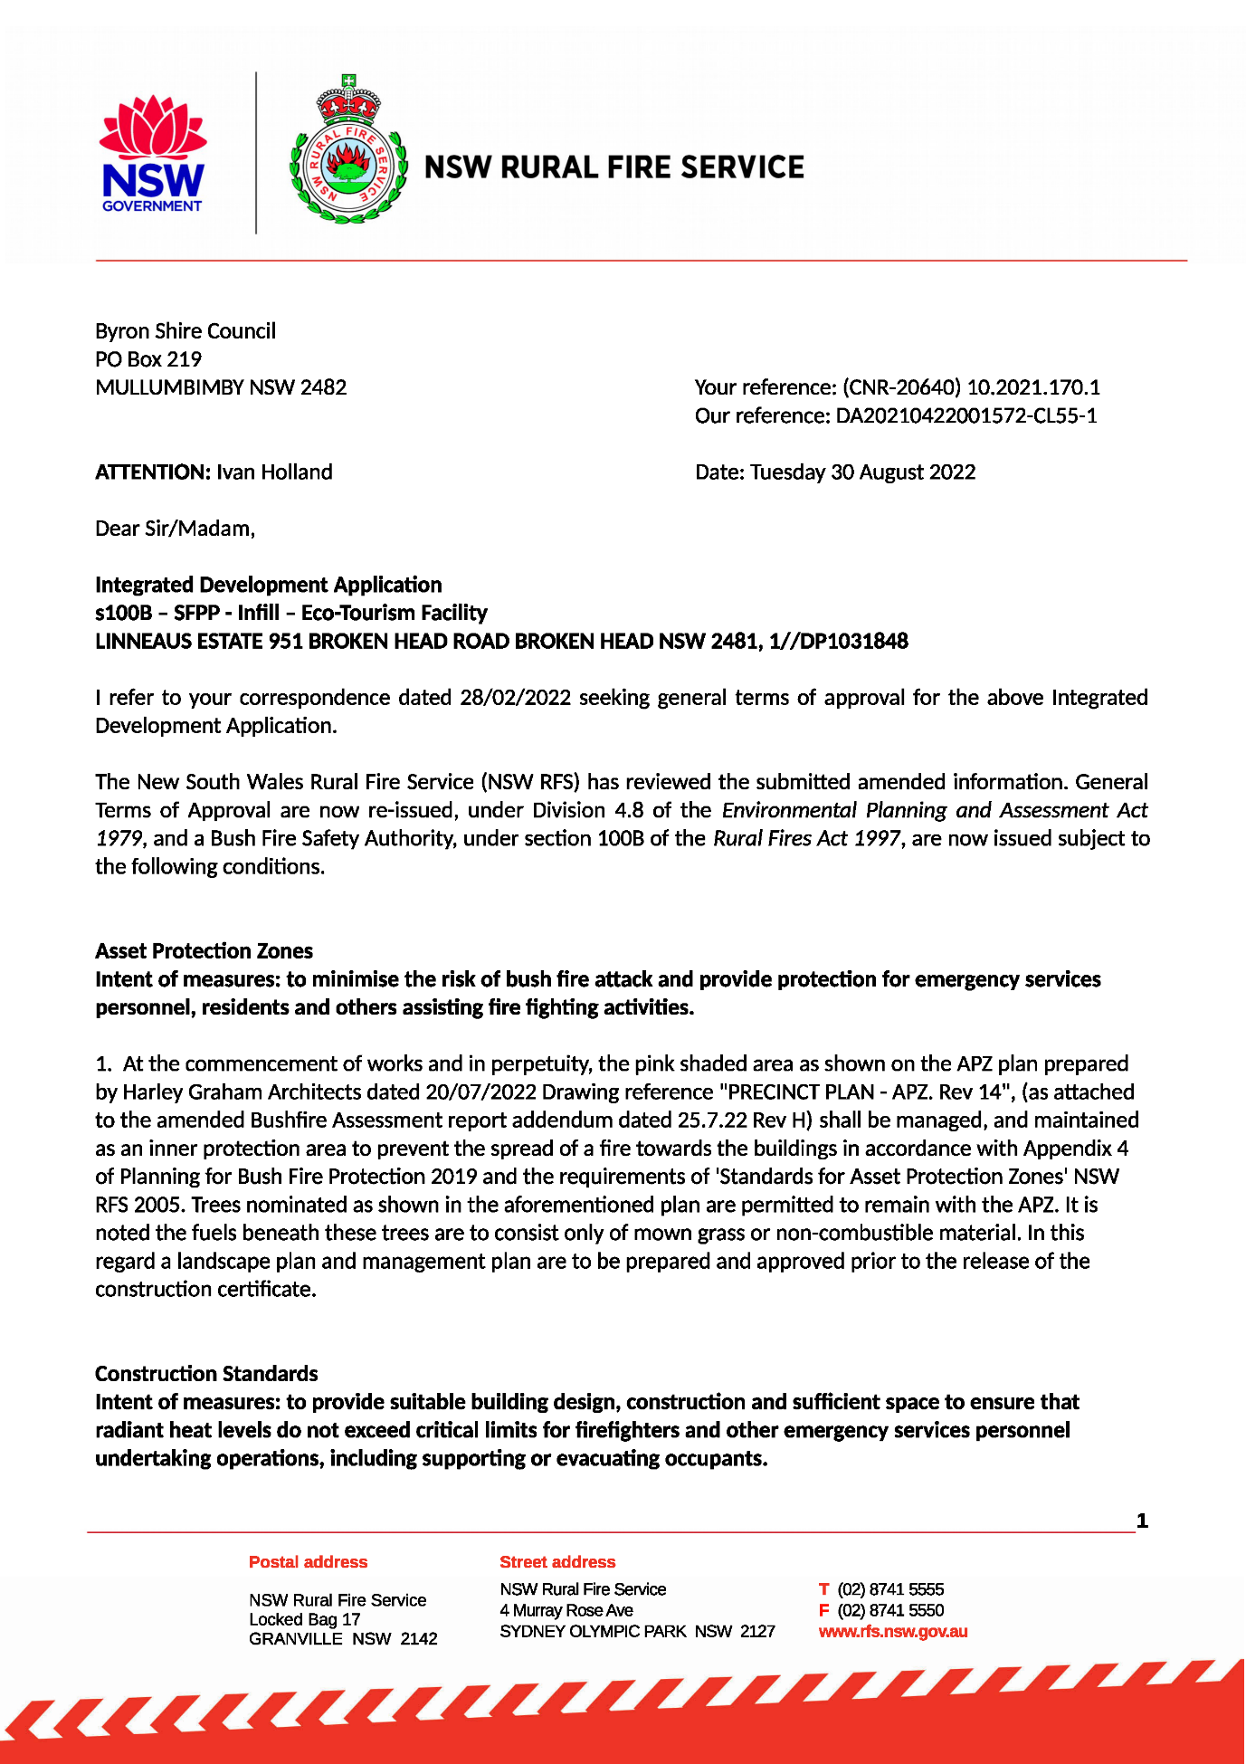
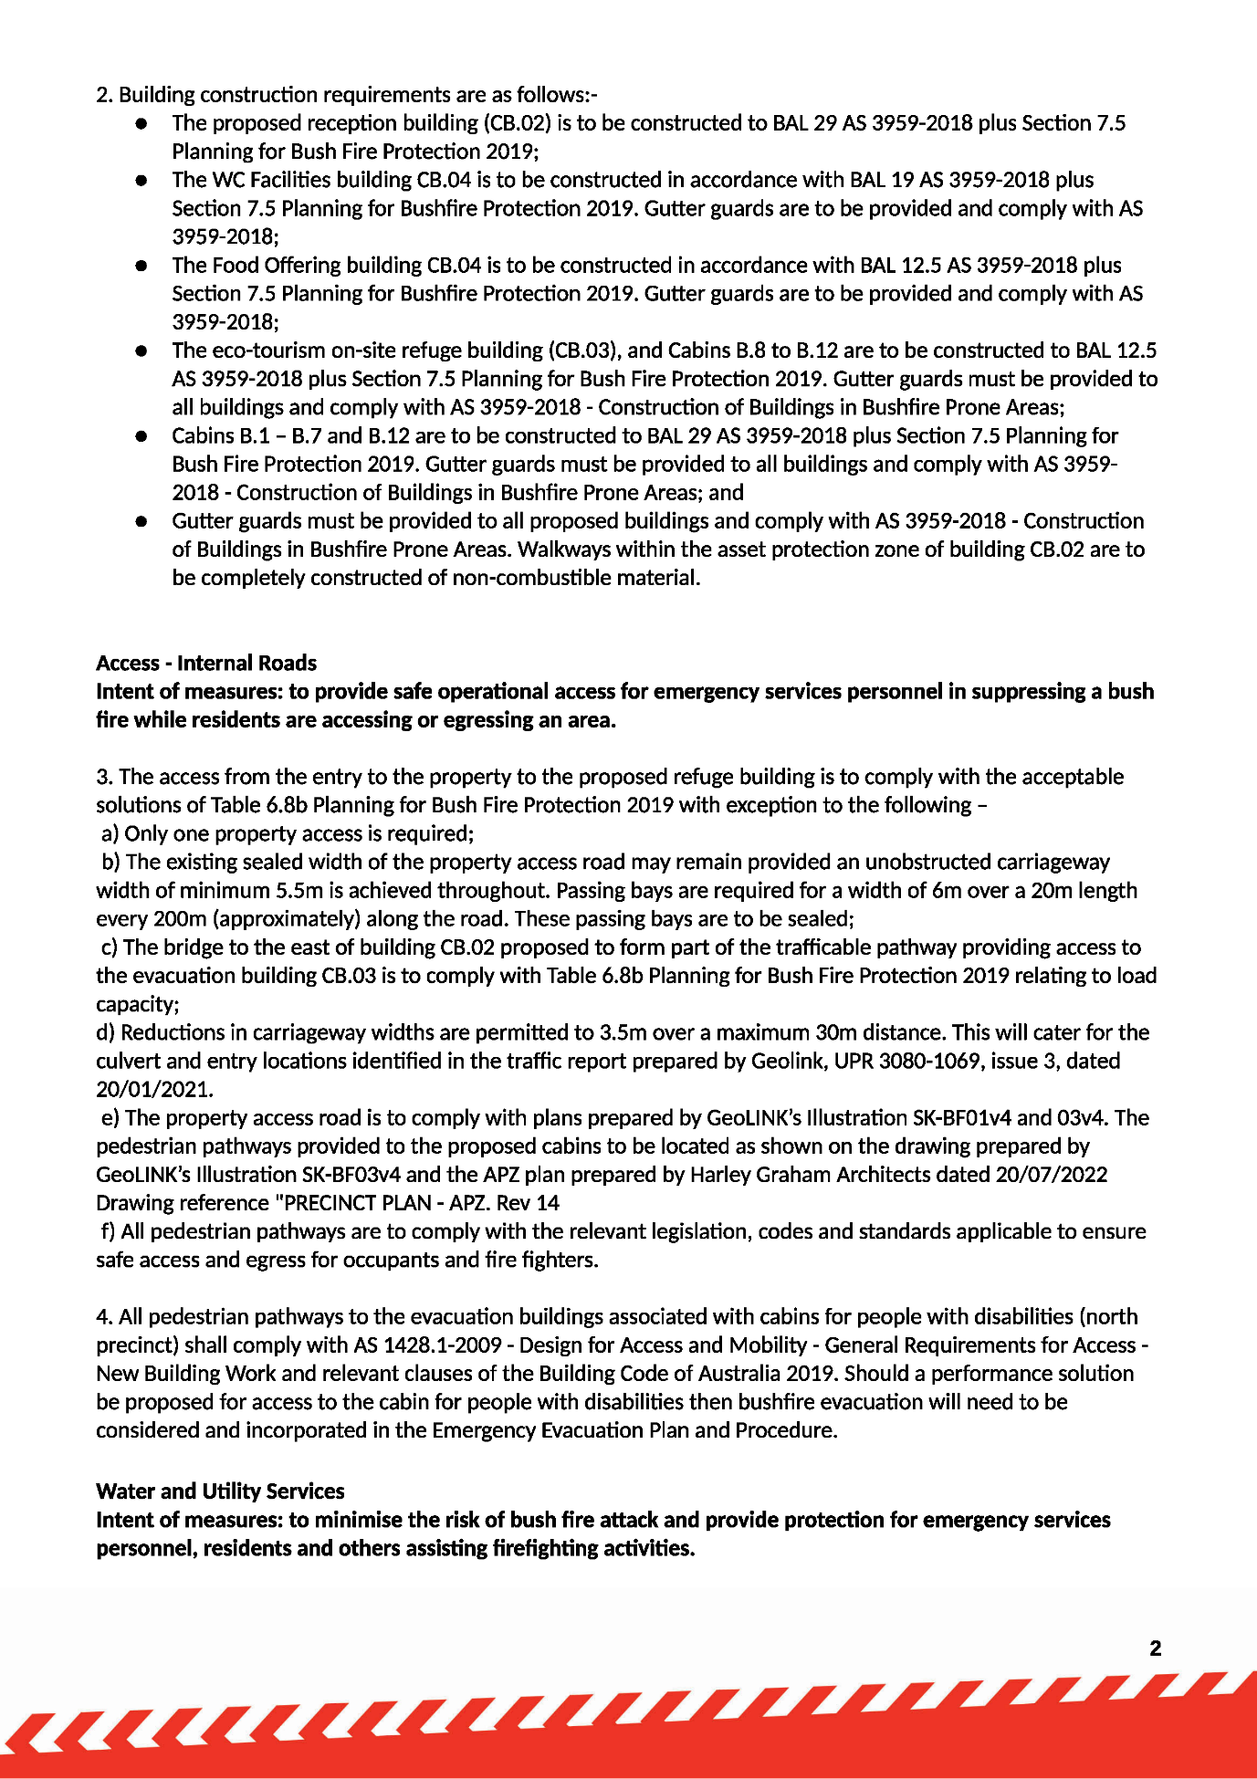
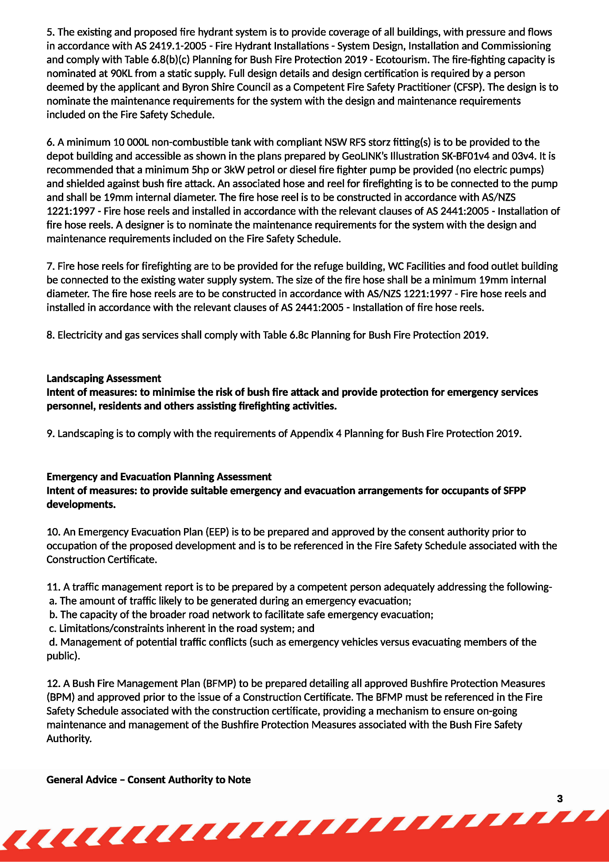
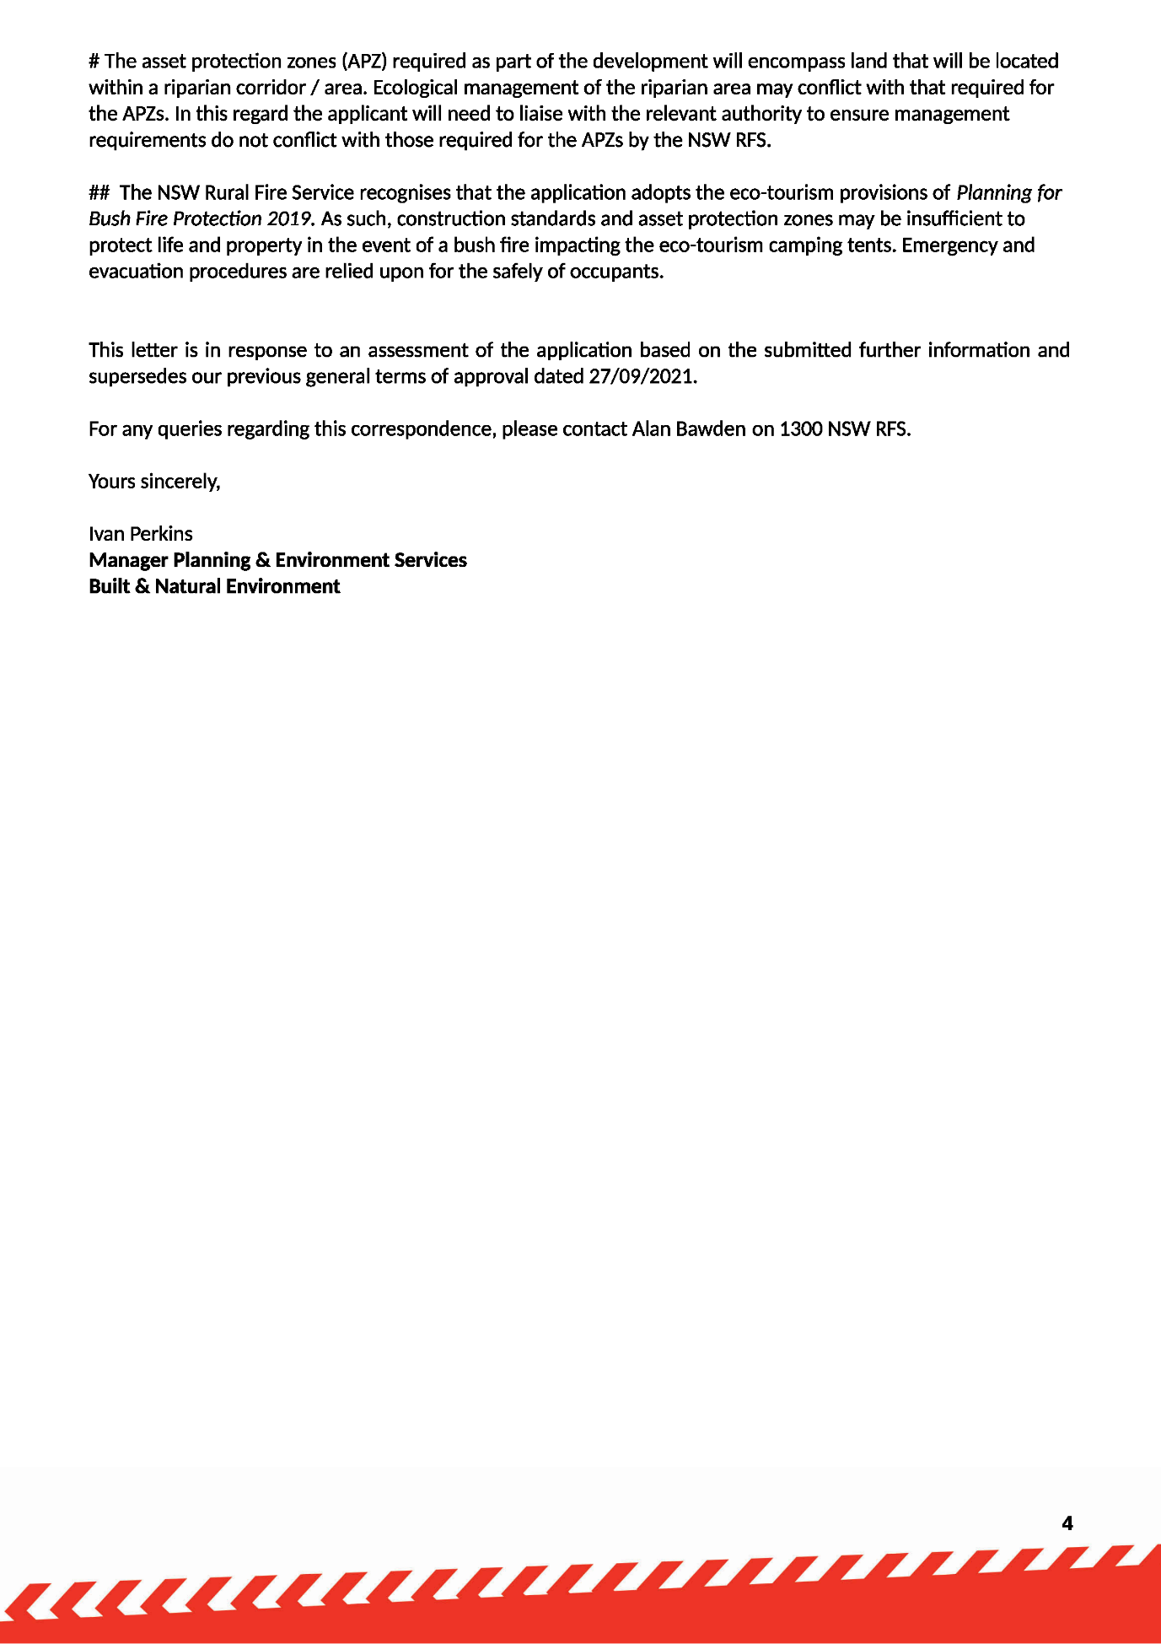
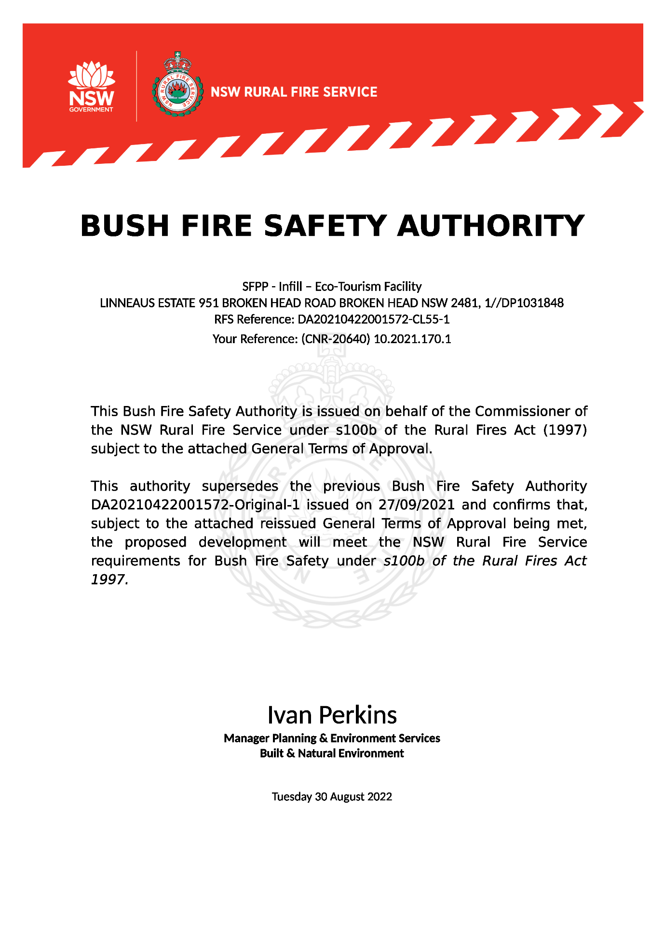

NOTES
Construction Certificate required:
This development consent is issued under the Environmental Planning and Assessment Act 1979 and does not relate to structural aspects or specifications of the building under the Building Code of Australia. All buildings and alterations require the issue of a Construction Certificate prior to works commencing. Application forms are available from the customer services counter or Council’s website www.byron.nsw.gov.au

Principal Certifying Authority:
Work must not commence until the applicant has:-
a. appointed a Principal Certifying Authority (if the Council is not the PCA); and
b. given Council at least two days notice of the intention to commence the erection of the building. Notice must be given by using the prescribed ‘Form 7’.
c. notified the Principal Certifying Authority of the Compliance with Part 6 of the Home Building Act 1989.

Occupation Certificate required:
The building must not be occupied until the Principal Certifying Authority has issued an Occupation Certificate.

Protection of the Environment Operations Act 1997:
It is an offence under the provisions of the Protection of the Environment Operations Act 1997 to act in a manner causing, or likely to cause, harm to the environment. Anyone allowing material to enter a waterway or leaving material where it can be washed off-site may be subject to a penalty infringement notice (“on-the-spot fine”) or prosecution.

Penalties apply for failure to comply with development consents
Failure to comply with conditions of development consent may lead to an on the spot fine being issued pursuant to section 4.2(1) of the Environmental Planning & Assessment Act 1979 or prosecution pursuant to section 9.50 of the Environmental Planning & Assessment Act 1979.

Plumbing Standards and requirements.
All Plumbing, Water Supply, Sewerage and Stormwater Works shall be installed in accordance with the Local Government Act 1993, Plumbers Code of Australia and AS/NZS 3500 Parts 0-5, the approved plans (any notations on those plans) and the approved specifications. Any plumbing inspections required under a Section 68 Approval are to occur in accordance with that approval.

Enclosed public places (smoke-free environment)
Environment Act 2000 and the Smoke-Free Environment Regulation 2000 and the guidelines in the Regulation for determining what an enclosed public place is. Enquiries may be directed to the NSW Department of Health. The legislation may be viewed on: http://www.legislation.nsw.gov.au/maintop/scanact/inforce/NONE/0

Swimming pool discharge (reticulated systems)
Swimming pool waste - irrespective of the filtering system is to be disposed into the property’s house drainage - sewerage system via an overflow relief gully with a 100mm visible air gap in accordance with AS/NZS 3500.2, Section 10.9 & Figure 10.2.

This activity is now an exempt activity and does not require approval under Section 68 of the Local Government Act.

If, however, site conditions prevent discharge through the existing gully and a new gully is required, this activity will require an approval under S68 before this work can commence.
Note also that this activity must be carried out by a licensed plumber.

Relics Provisions- Advice
In relation to the exposure of relics, the Heritage Act 1977 requires that if:
- a relic is suspected, or there are reasonable grounds to suspect a relic in ground, that is likely to be disturbed damaged or destroyed by excavation; and/or
- any relic is discovered during excavation that will be disturbed, damaged or destroyed by further excavation;

Those responsible for the discovery must notify nominated management personnel who will in turn notify the Heritage Council of New South Wales or its delegate, the Office of Environment and Heritage, NSW Heritage Branch, and suspend work that might have the effect of disturbing, damaging or destroying such relic until the requirements of the NSW Heritage Council have been satisfied (ss139, 146).

Additional conditions if swimming pools approved
Details of pool fence required
The application for a Construction Certificate is to include plans and specifications that indicate the details of the fencing around the swimming pools for each cabin in accordance with the Swimming Pools Act 1992 and AS 1926.1.

Such plans and specifications must be approved as part of the Construction Certificate.

Swimming pool fencing
Swimming pool fencing is to comply with the requirements of the Swimming Pools Act 1992 and Regulations.

Pool Safety Sign
The occupier of the premises must ensure that there is a sign in the immediate vicinity of the swimming pool bearing the words ‘Young children must be supervised when using this swimming pool’. The sign is to be a prominent position and be otherwise in accordance with clause 9 of the Swimming Pools Regulation.

A pool resuscitation sign is to be installed in a conspicuous location within the pool area to the satisfaction of the Principle Certifying Authority.

Pool backwash in rural areas
Pool water disposal and backwash is to be directed to a soakage trench located in such a location as to not cause any nuisance to adjoining properties or damage to any structures.

Swimming pool pump location
The filter pump is to be located such that noise from its operations does not cause a nuisance to adjoining residents. If necessary, an acoustic enclosure must be provided around the pump to achieve the required noise attenuation.

